Domain Controller

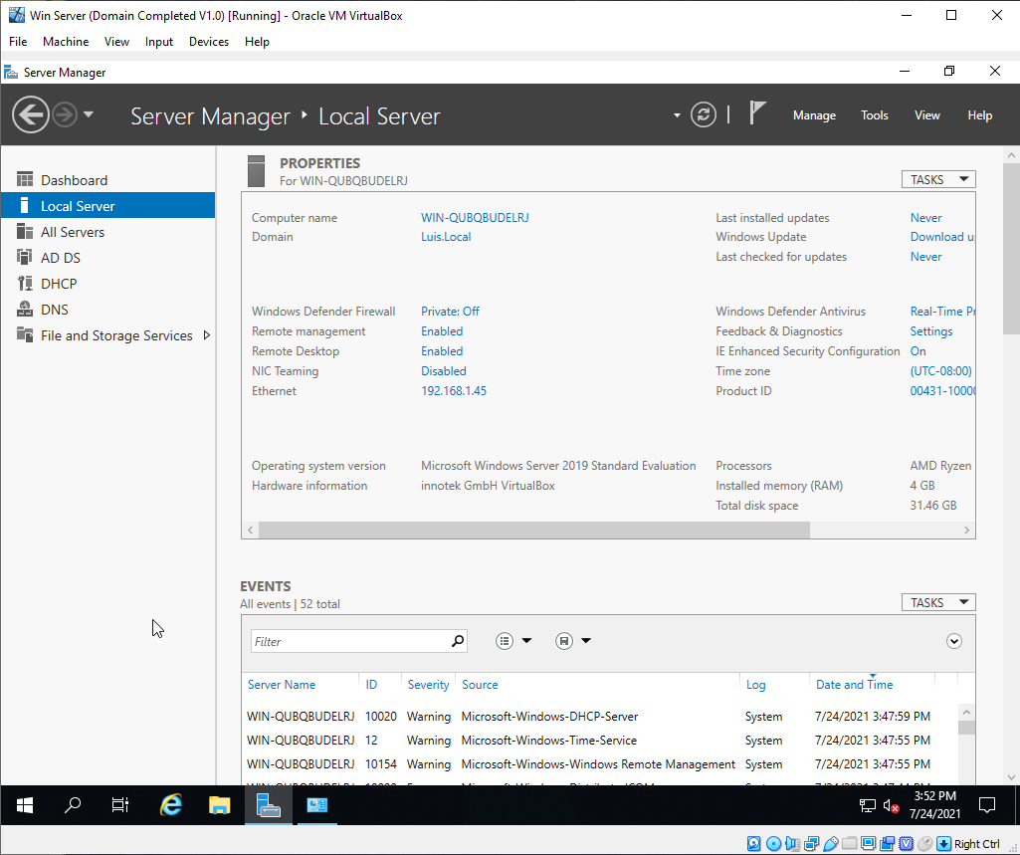

Static IP

Configure in order to allow the window server to create a DNS

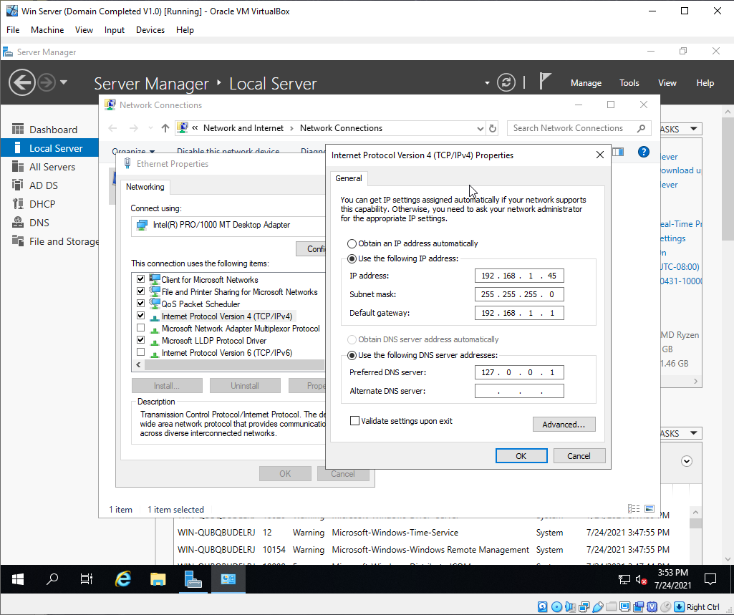

Install Domain Services, DNS and DHCP

Nothing much but name the Domain and allow for the DNS and DHCP to install configuration (Easy Step). You do nothing much.

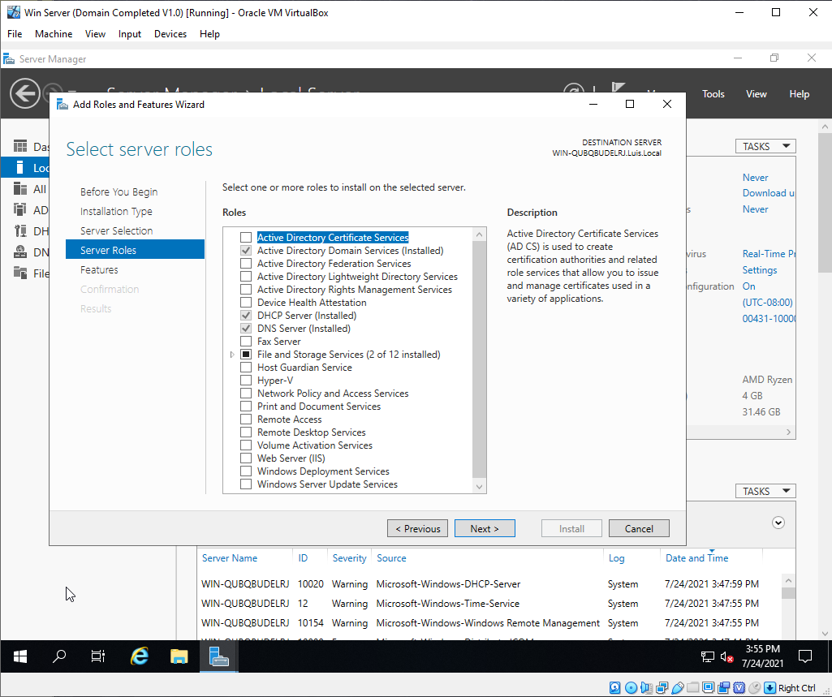

Show it can connect with others and allow for domain to work by testing it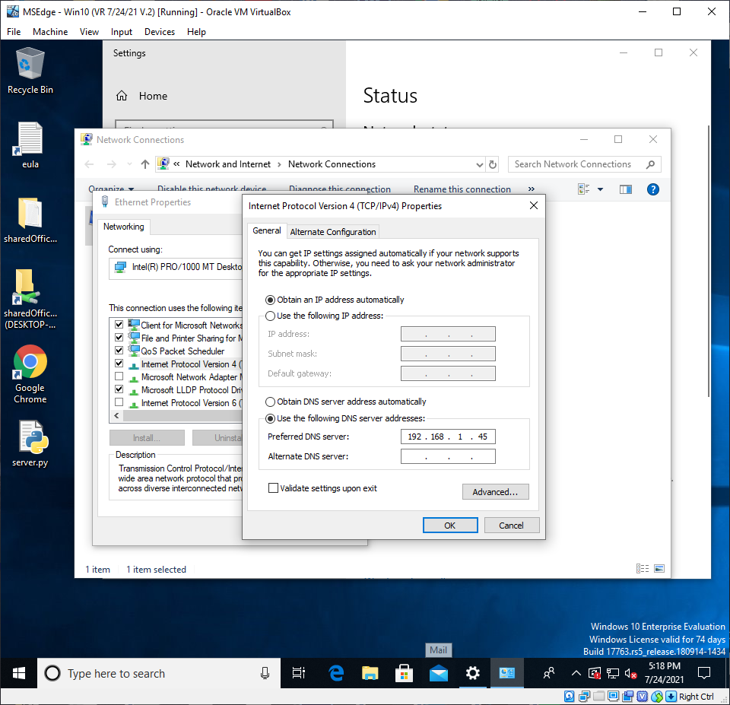

Connection to Domain

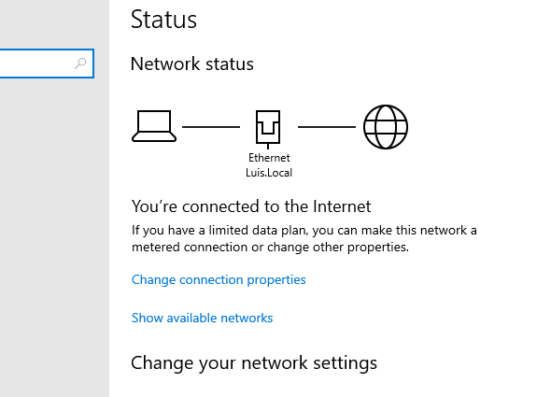

Create Scope on DHCP

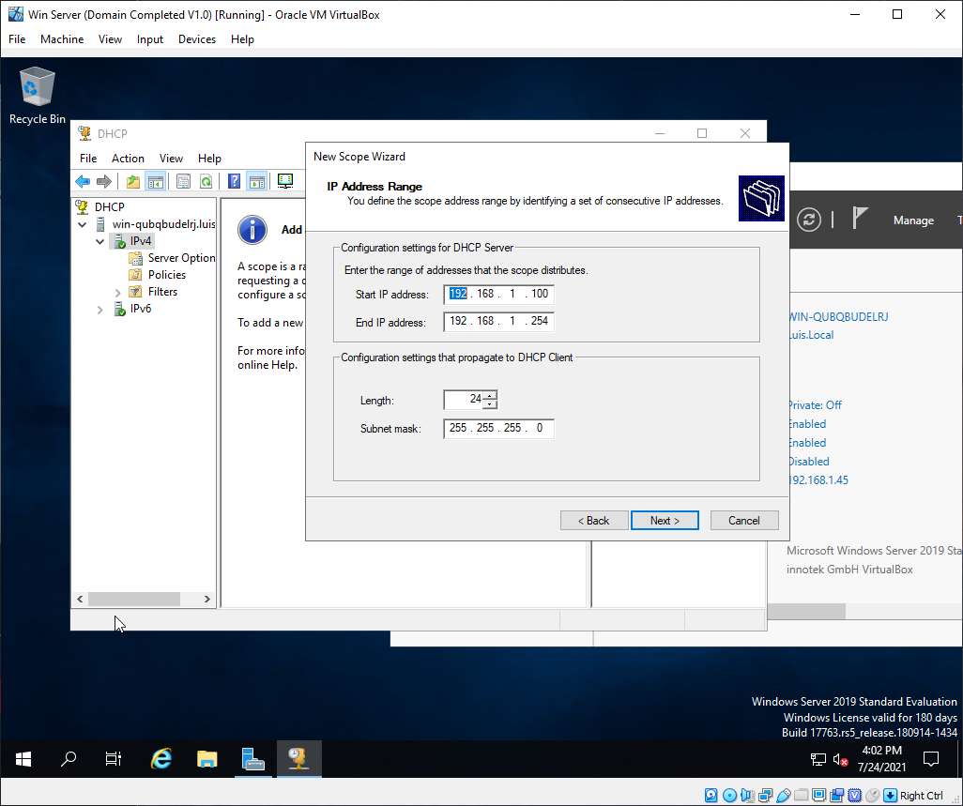

Scope Part 2

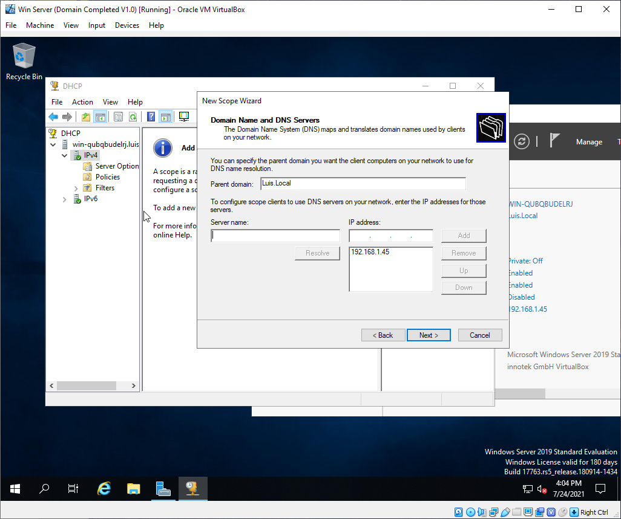

Scope Final

